GROUP 5
TECHNICAL DOCUMENTATION

I. Object Oriented Programming Implementation
Player.Js
Inheritance:
In our code we initialize a BasePlayer where it contains functions and variables that the Players and System will use, then Player 1 and Player 2 inherits from the Parent BasePlayer to allow code reuse.
Code Snippet
Parent Class | Player 1 Inherits | Player2 Inherits
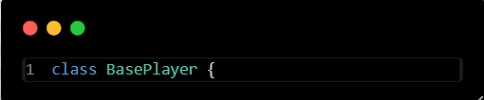 | 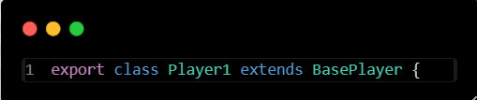 | 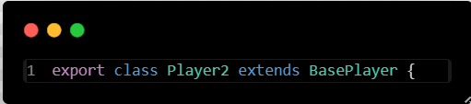
So, instead of duplicating logic for each player, we can just define it once in BasePlayer and let child classes Player1 and Player2 inherit it. Also, each child can the customize only what is different for them like animations, starting position, and facing direction

Encapsulation:
In implementing Encapsulation, we use private fields inside the Parent Class and setup a getter and setter methods access to these fields. This allows us to hides internal implementation details, and protect the state of the object from being modified directly in the console by other player and outside logics. This ensures that the player’s properties (like position, velocity, or animation) can only be changed in controlled ways, reducing bugs and improving maintainability
Code Snippet
Implementation of Private Fields | Example of Implementation of Getter & Setter
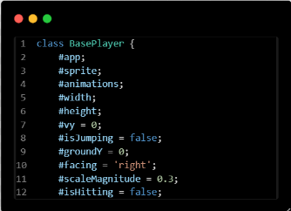 | 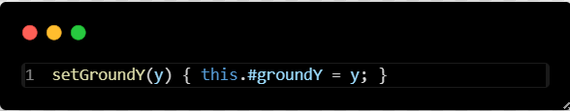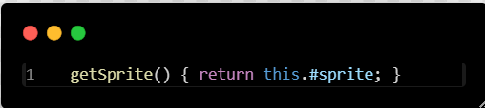

Abstraction:
For the Abstraction implementation, we created the function move(), jump(), and setState, which defines what a player can do without exposing the implementation details, like how textures are handled, scaled, or animated.
This allows other parts of the game system to interact with the player object through simple, clear interfaces, while hiding the complexity of the animation logic, physics calculations, and internal state management
Code Snippet
Snippet of abstraction of logic | Example of Implementation in Player Movement
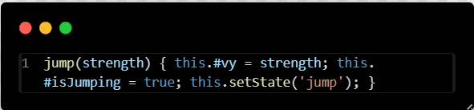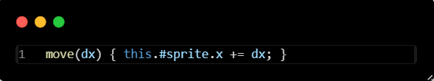 | 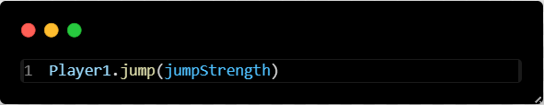

This allows us to make it easier to work with player objects and maintain the code without needing to understand the function itself.

CollisionHandling.js
Polymorphism:
In our collision system, we applied polymorphism by creating a abstract function called CollisionLogic() inside the parent class where ChildClass are required to use it. The child classes WallCollision, NetCollision, and ShuttleCollision all override this method with their own collision handling logic
This allows the game to call CollisionLogic() without needing to know which specific collision class it is as each child class provides its own specialized logic:
• WallCollision limits how far each player can move on the edges of the screen.
• NetCollision prevents players from passing through the net.
• ShuttleCollision handles shuttlecock bouncing, net interaction, and scoring.

Code Snippet
Setup of Polymorphism | Implementation of Polymorphism
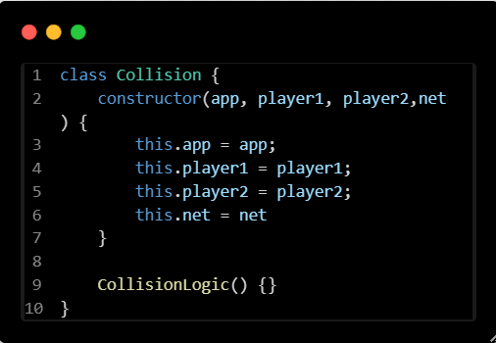 | 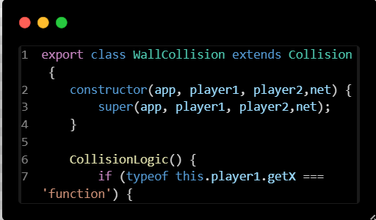 | 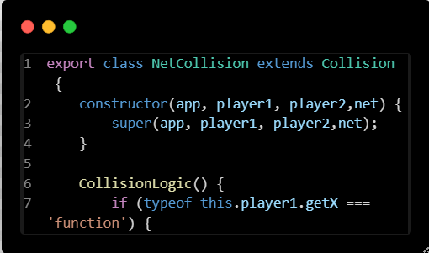
Because all child classes share the same method name, the game can process different collisions using a uniform interface. This makes our system flexible, extendable, and easy to maintain. Also new collisions can be added simply by creating a new subclass and overriding CollisionLogic().

ShuttleCock.js
Encapsulation:
For the Shuttlecock class, we implemented encapsulation by using multiple private fields aswell such as #position, #velocity, #gravity, #sprite, and #alive. These variables cannot be modified directly from outside the class, this prevents external code from accidentally breaking the shuttlecock's physics or state.
Code Snippet
Implementation | Example of Getter & Setter in ShuttleCock
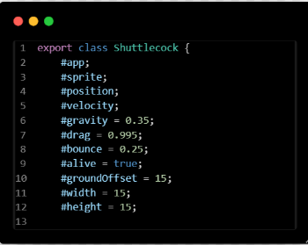 | 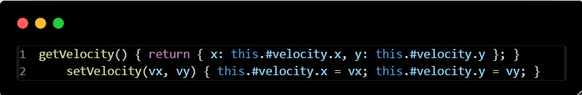

And control is provided through the public getter and setter methods like getPosition(), SetPosition, etc. This ensures the shuttlecock stay safe when any updates happen to the object. This also protects the shuttlecock's behavior from being changed, maintaining stability and preventing bug caused by unintended changes from other game logic

Abstraction:
We also applied abstraction for the Shuttlecokc class by showing interface for interacting with its projectile, while hiding the complex physics calculations inside private fields and methods such as update(), hiyBy(), reset(), etc.
Code Snippet
Abstraction Example for Shuttlecock | Implementation Snippet
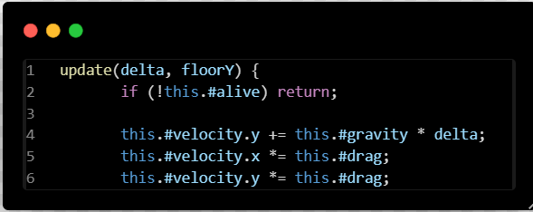 | 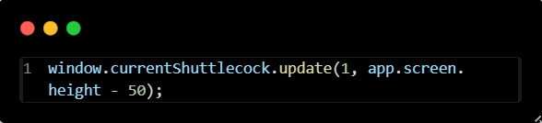

Allowing other parts of our game to interact with the shuttlecock without knowing anything about how gravity, drag, bounce, velocity, etc. work
This makes the shuttlecock simple to use while the intricate physics and animations remain hidden inside the class. As a result, our code becomes easier o manage, modify, and extend

AudioSystem.js
Encapsulation:
The AudioSystemm class uses Encapsulation by storing all audio data inside private field such as #sound, #music, #currentMusic, etc. With that, this make them hidden from outside our code, preventing again anything outside the class from directly modifying audio or breaking its state
Code Snippet
Implementation | Example of the Getter & Setter
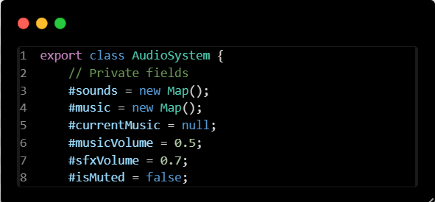 | 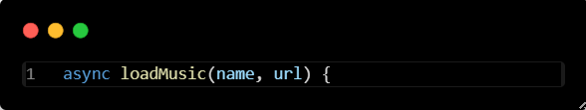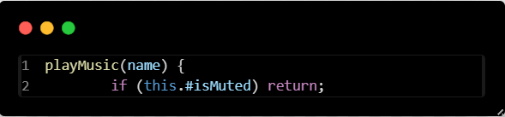

So instead of exposing raw audio elements, the class provides safe, controlled public methods such as loadSound(), PlayMusic(), SetMusicVolume(), etc.

This ensures the game can play audio, adjust volum, or toggle mute without accessing private data directly. Encapsulation protects the integrity of the audio system, avoids unexpected behavior caused by external code, and makes the audio easier to maintain and debug

II. Gameplay Documentation

